|  |
| --- |
| **Institute of Technology Blanchardstown** |
| StreaMe |
| Live Streaming Cross-Platform Broadcasting Client |
|  |
| **Benoit Brayer, Nans Plancher, Romaric Delaunoy** |
| **Nans Plancher**  **Romaric Delaunoy** |
| **01/01/2013** |

|  |
| --- |
|  |

Submitted in part fulfilment for the degree of

**B.Sc. Computing**

School of Informatics and Engineering,

Institute of Technology Blanchardstown,

Dublin, Ireland

# Declaration

I hereby certify that this material, which I now submit for assessment on the programme of study leading to the award of Degree of **B.Sc. in Computer Science** in the Institute of Technology Blanchardstown, is entirely my own work except where otherwise stated, and has not been submitted for assessment for an academic purpose at this or any other academic institution other than in partial fulfilment of the requirements of that stated above.

Signed:________________________ Dated: ____/_____/_____

# Abstract

# Contents

Declaration 1

Abstract 2

Contents 3

Illustration Table 6

I. Chapter 1: Introduction 7

I.1 Introduction 7

I.2 Project Design 7

I.3 Objectives 7

I.4 Motivation 7

I.5 Technologies 7

II. Chapter 2: Literature Review 8

III. Chapter 3: System Analysis 9

III.1 Overview 9

III.1.1 Uses case 10

III.2 Functional requirements 10

III.2.1 Store the project 10

III.2.2 Configure the streaming platform and parameters 10

III.2.3 Add media sources into the project 10

III.2.4 Send the stream to a server 10

III.2.5 Display stream in the software 10

III.2.6 Display feedback of the streaming 11

III.3 Use Cases 11

III.3.1 Create a new project 11

III.3.2 Load the source available 11

III.3.3 Add a source into the project 12

III.3.4 Remove a source from the project 12

III.3.5 Choose a broadcasting platform 13

III.3.6 Configure the streaming parameters 13

III.3.7 Save the project 14

III.3.8 Save the project as 15

III.3.9 Open a project 16

III.3.10 Rename a project 16

III.3.11 Start streaming 16

III.3.12 Stop streaming 17

III.3.13 Streaming display 18

III.3.14 Streaming feedback 18

IV. Chapter 4: System Design 19

IV.1 User Interface Design 19

IV.1.1 Main Window 19

IV.1.2 Starting Assistant 20

IV.1.3 New Project 21

IV.1.4 Streaming Parameters 21

IV.1.5 Advanced Parameters 22

IV.1.6 Rename 22

IV.2 Functional Design 23

IV.2.1 Starting assistant 23

IV.2.2 New Project Assistant 23

IV.2.3 Streaming Parameters 24

IV.2.4 Advanced Parameters 24

IV.2.5 Rename 24

IV.3 Classes Design 25

IV.3.1 Design Pattern MVC 25

IV.3.2 Overall Class Diagram 25

IV.3.3 Class Diagram 26

V. Chapter 5: Implementation 27

V.1 Languages, Libraries and Tools 27

V.1.1 C++ 27

V.1.2 QT 27

V.1.3 Qt Creator 27

V.1.4 Phonon 27

V.1.5 FFMPEG 27

V.1.6 Broadcasting Platforms 27

V.2 Prototype Implementation 27

V.2.1 User Interface 27

V.2.2 Project File 27

V.2.3 Video Capture 29

V.2.4 Video Broadcast 29

V.2.5 Video Display 29

V.3 Linux Implementation 30

V.4 Installer on Windows and Linux 30

V.4.1 Windows 30

V.4.2 Linux 30

V.5 Others ??? 30

VI. Chapter 6: Testing and Evaluation 31

VII. Chapter 7: Conclusion and Further Work 32

VII.1 Further Work 32

VII.2 Conclusion 32

# Illustration Table

Figure III‑1 Use Case Diagram 10

Figure 2 Sequence Diagram Create a new project 11

Figure 3 Sequence Diagram Create a new project 12

Figure 4 Sequence Diagram Add a media source 12

Figure 5 Sequence Remove a source 13

Figure 6 Sequence Diagram Choose a broadcasting platform 13

Figure 7 Sequence Diagram Configure the streaming parameters 14

Figure 8 Sequence Diagram Save the project 15

Figure 9 Sequence Diagram Save the project as 15

Figure 10 Sequence Diagram Open a project 16

Figure 11 Sequence Diagram Rename a project 16

Figure 12 Sequence Diagram Start the streaming 17

Figure 13 Sequence Diagram Stop the streaming 17

Figure 14 Sequence Diagram Streaming display 18

Figure 15 Sequence Diagram Streaming feedback 18

Figure 16 Main widow draft 19

Figure 17 Starting assistant window draft 20

Figure 18 New project assistant window draft 21

Figure 19 Streaming parameters window draft 21

Figure 20 Advanced parameters window draft 22

Figure 21 Rename window draft 22

Figure 22 Interaction Diagram Starting Assistant 23

Figure 23 Interaction Diagram New Project Assistant 23

Figure 24 Interaction Diagram Streaming Parameters 24

Figure 25 Interaction Diagram Advanced Parameters 24

Figure 26 Interaction Diagram Rename 24

Figure 27 StreaMe Class Diagram 26

Figure 28 Example of project file 28

# Chapter 1: Introduction

## Introduction

Description of the project

## Project Design

Brief description of how the project is use

## Objectives

What the system should be able to do

## Motivation

## Technologies

Technologies use

# Chapter 2: Literature Review

# Chapter 3: System Analysis

## Overview

The system must be capable of capturing video from camera such as a webcam and audio from a microphone of a computer and send a video and audio stream to a broadcasting platform to play it in live.

In order to address these issues six key elements were defined:

1. Create a project

The application must be capable to assist the user for the creation of a new project. Also the application must give the possibility to save and load configurations to the user by using project files.

1. Configure parameters

The possibility of fully configure the audio and video quality, and the size of frames before sending the stream must be given to the user but an simplified configuration must be available for users based on the user internet broadband speed.

1. Add media sources into the project

Adding video and audio source must be easy and intuitive.

1. Send the stream to a server

Sending audio and video to the broadcasting platform must be automatically available when the platform parameters are filled in.

1. Display stream in the software

A player must be present into the interface to show the content which is currently streaming.

1. Display feedback of the streaming

Feedback on the streaming must be given to the user into the interface.

### Uses case

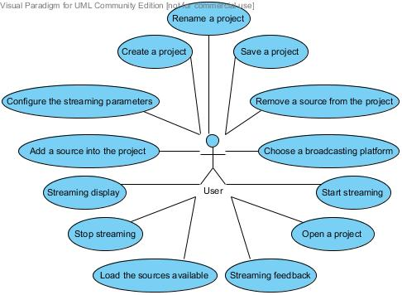

Figure III‑1 Use Case Diagram

## Functional requirements

### Store the project

1. Ensure the application can access the repertory where the user wants to save the project.
2. Ensure the project file is not corrupted when the application have to load it.

### Configure the streaming platform and parameters

1. Ensure to allow only coherent values using combo-box widgets and set a range of values for the upload broadband speed selection.
2. Ensure to limit the allowed platform to the platform where the application is able to stream to.

### Add media sources into the project

1. Ensure to not add two times the same source to the used source
2. Ensure that the is only one source for each type of source (video and audio)

### Send the stream to a server

1. Ensure that image and video codecs are the codecs allowed by the broadcasting platforms
2. Ensure to ask the user if something is wrong with the broadcasting platform like a bad streaming key, the broadcasting platform server down, no source defined as used.

### Display stream in the software

1. Use a Queue store each video and audio to play in the player and automatically reload this queue to keep playing the streaming since the streaming was not stopped

### Display feedback of the streaming

1. Ensure to display every useful feedback into the interface and to filter every useless feedback.

## Use Cases

For each use case: description, diagrams (main use case first)

### Create a new project

The user wants to create a new project.  
The user clicks on the “File” menu and click on the “create new project “button in the interface.  
A new window appears and asks the user to give a name to the project.  
After clicking on the create button, the new project is created and the streaming configuration windows appears.

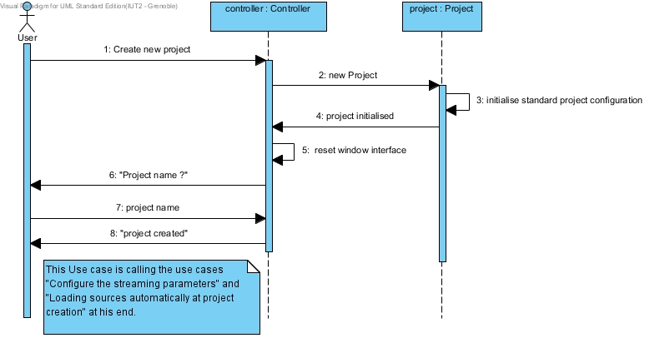

Figure 2 Sequence Diagram Create a new project

### Load the source available

When starting a new project the sources available are automatically load and appear in the sources list of the software.

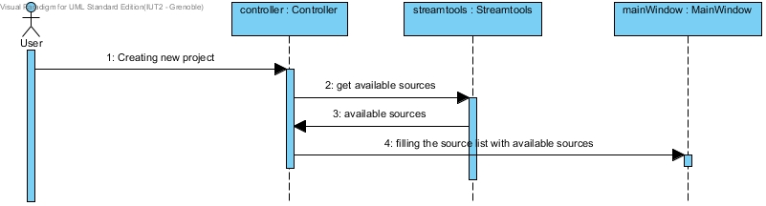

Figure 3 Sequence Diagram Create a new project

### Add a source into the project

When the user wants to add a source into his project he simply click on the source wanted in the source list and click on a button with an arrow to the right to add this source into the project, he can now see his selected source into the project source list call “Show”.

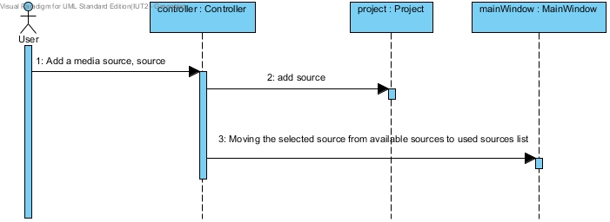

Figure 4 Sequence Diagram Add a media source

### Remove a source from the project

When the user wants to remove a source from the project he click on the source wanted into the source list of the project named “show” and click on the left arrow, he can see that the source is no more into the project list but in the source list.

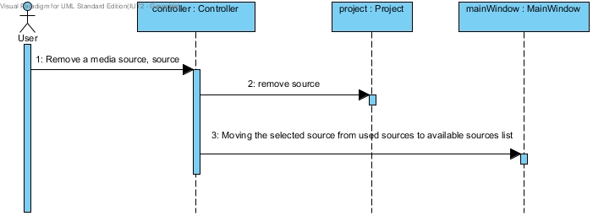

Figure 5 Sequence Remove a source

### Choose a broadcasting platform

The user wants to choose a broadcasting platform. He clicks on the menu “Config”, then “Choose platform“, a window appear with the platforms he can choose, he can select a platform then enter a streaming key and click on the « ok » button. He can access to the streaming parameters too.

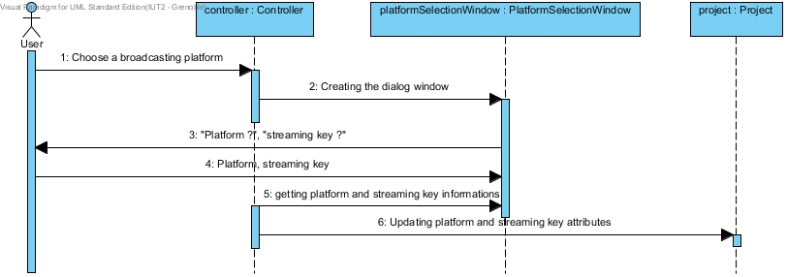

Figure 6 Sequence Diagram Choose a broadcasting platform

### Configure the streaming parameters

The user wants to configure the streaming parameters.  
The user clicks on the “Config” menu and click on the “Configure parameters” button in the interface.  
A new window appear witch allow the user to configure the broadcasting platform parameters (size, format, bitrate, speed). The user validate the changes by clicking on the ok button.

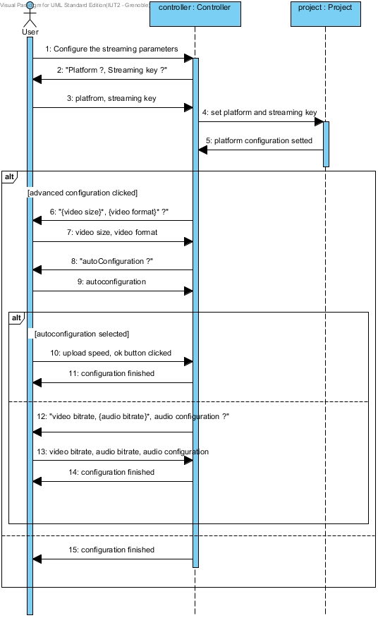

Figure 7 Sequence Diagram Configure the streaming parameters

### Save the project

After configuring the project, the user can save it into a file, which can be reuse later. All parameters defined can be saved in the file, like the sources selected, the configuration, the platform chosen.  
To save the project, the user has to go on the “file” menu, by clicking on “save” the save function is called if a project file is already created, else the function “save as” is called.

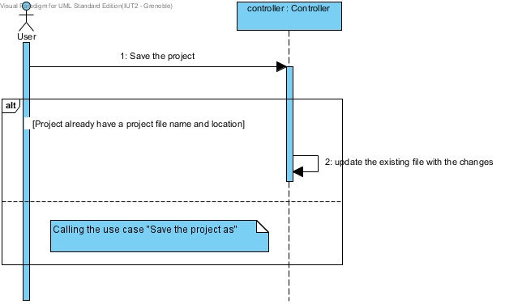

Figure 8 Sequence Diagram Save the project

### Save the project as

When the user want to save his project into a new project file, he go to the “file” menu, click on the “save as” button, he has to select a new path and a name for the project file, the parameters saved are the same than in the “save the project” use case.

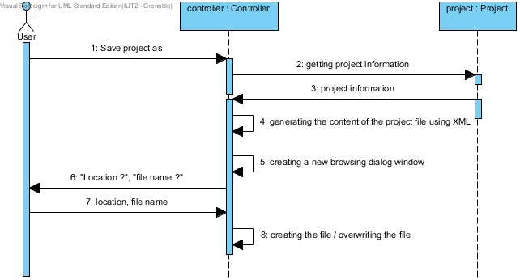

Figure 9 Sequence Diagram Save the project as

### Open a project

The User want to open an existing project, he go on the “file” menu and select “open a project “, he has to select the file of the existing project and click on ok.

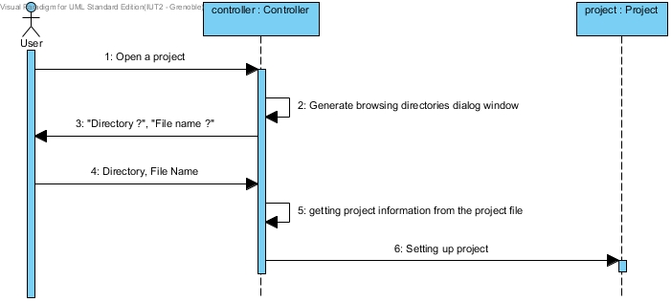

Figure 10 Sequence Diagram Open a project

### Rename a project

The user can rename a project when he want to, he just has to go in the “edit” menu and click “rename” a new window appears where he can enter the new name of the project and click on “ok” to validate it.

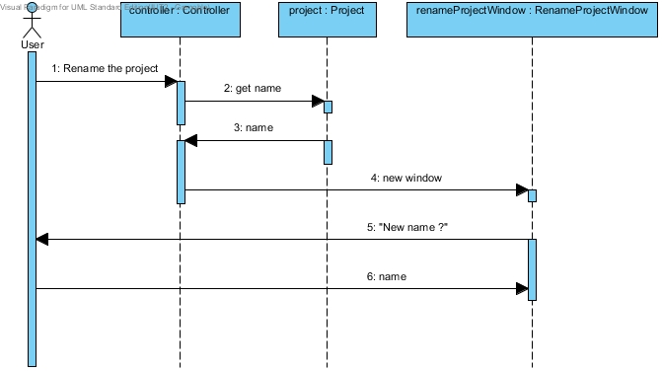

Figure 11 Sequence Diagram Rename a project

### Start streaming

The user wants to start streaming. If he has selected some sources for his project and configure the streaming parameters he can click on the play button in the main window or in the “Show” menu, then the streaming start and after a few seconds the stream is displayed into the main window.

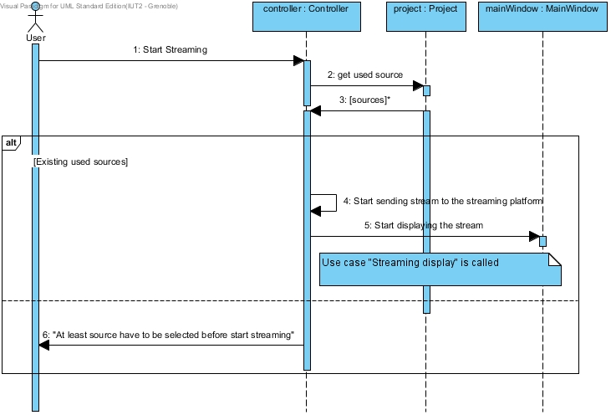

Figure 12 Sequence Diagram Start the streaming

### Stop streaming

The user can at every-time stop the streaming, by clicking on the button stop in the main window or in the “show” menu. Clicking on stop will stop the display of the stream and the broadcast on the streaming platform. When the user stops the streaming, the project is still available. If he wants to stream again he just has to click on the play button again.

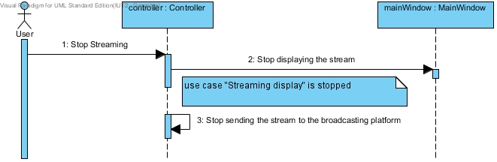

Figure 13 Sequence Diagram Stop the streaming

### Streaming display

When the user wants to stream the result of what he sent is displayed into the software with just a little delay, the user can control the sound of the output.

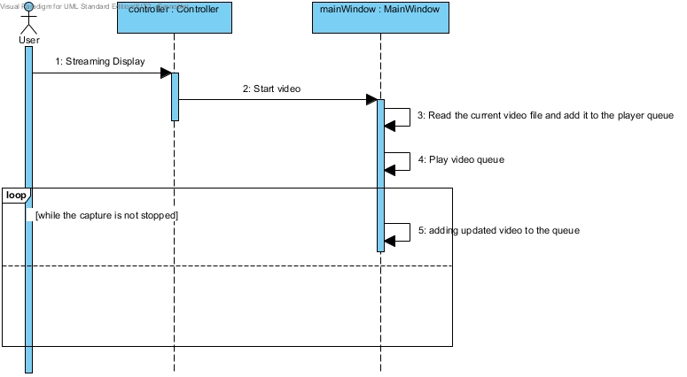

Figure 14 Sequence Diagram Streaming display

### Streaming feedback

When the user is sending a stream he also has a text feedback into the software that will tell the state of the streaming and of the source capture.

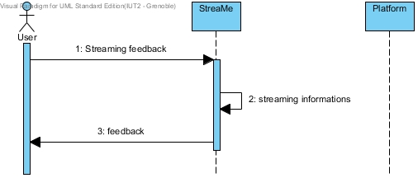

Figure 15 Sequence Diagram Streaming feedback

# Chapter 4: System Design

This chapter will outline how the software works in term of display and implementation; first we will take a look to the interface design.

## User Interface Design

The user interface must allow the user to create a project, select some sources, configure the streaming and start it.

To do that we have a few different window. Each window has its own functionality, but all the software is depending on one window, the main one, which we will describe first.

### Main Window

This window is the main window of the software, this is the most important window of the project, all the functionalities are depending on this window.

We have a menu where we can access to the project functionalities, the streaming parameters, the sources selection and where we can start and stop the streaming.

A list of the sources available is displayed in this window and we can add or delete a source to the show by clicking on the arrows between the two lists.

A player is also available where we have the streaming display, we can click on play and stop to play and stop the streaming, we also have a volume slider to control the sound in output.

The stream time is also displayed, this is the time since the stream is started.

And finally we have two tabs, one for the software feedback and one for the ffmpeg feedback (the streaming feedback), and we also have a status bar that display the streaming status (started, stopped).

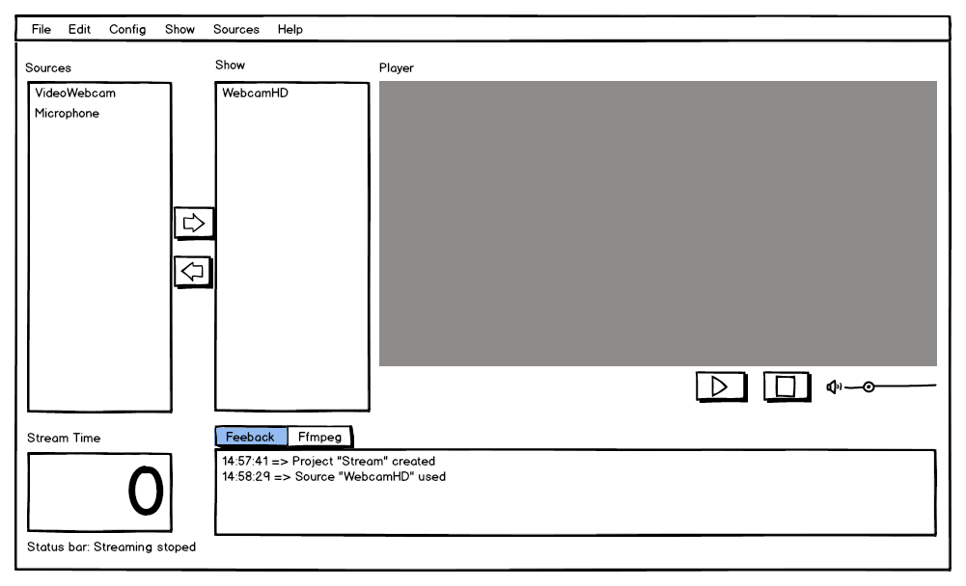

Figure 16 Main widow draft

### Starting Assistant

The starting assistant window is a window that is automatically displayed when we start the project.

It simply propose to the user to create a project or to open one, the user can skip this window but everything in the main window is disable until a project is created or opened.

If create project is selected the new project window is displayed, if open project is selected the open project window is displayed.

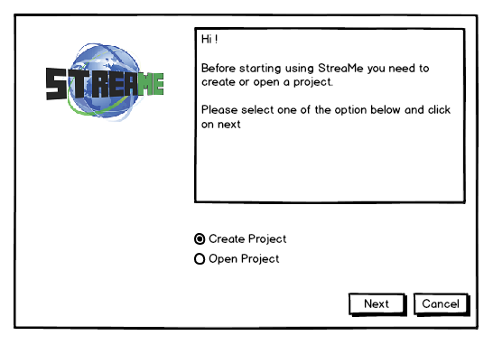

Figure 17 Starting assistant window draft

### New Project

The new project window is the window displayed when the user choose to create a project in the menu or with the starting assistant.

The user just has to enter a project name and click to next, that will display the streaming parameters window.

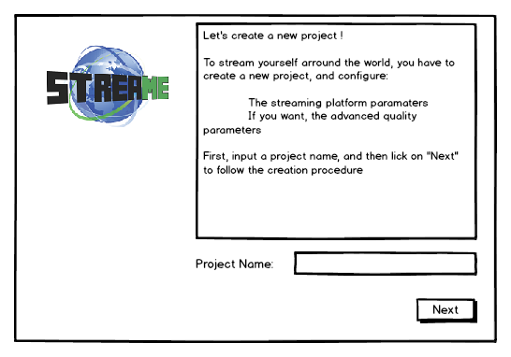

Figure 18 New project assistant window draft

### Streaming Parameters

The streaming parameters window make the user choose a streaming platform and enter the streaming key to send a stream on this platform, the streaming key is something a platform gave to a user when he create an account on it, it is obligatory to send a stream on a platform.

After selected a platform and enter the streaming key the user can validate by clicking on ok or configure the advanced parameters by clicking on advanced

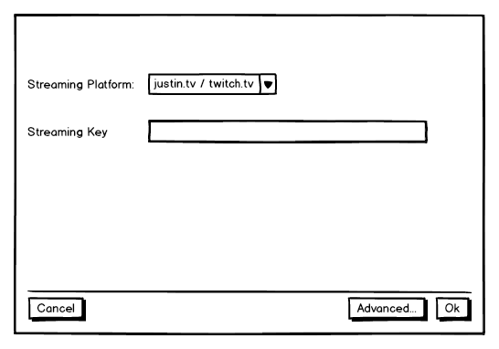

Figure 19 Streaming parameters window draft

### Advanced Parameters

The advanced parameters window allows the user to configure the parameters he want for his streaming.

He can select the size and the format of the video.

He can enable or not the auto configuration, if it is enable he just can change the upload speed, if the auto configuration is disable he can change more parameters like the video bitrate, the audio bitrate and format (mono, stereo).

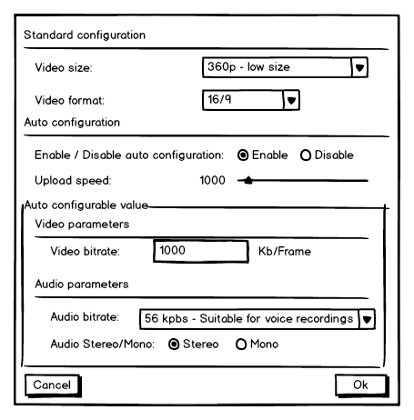

Figure 20 Advanced parameters window draft

### Rename

The rename window simply allows the user to change the name of the project, he can enter the new name and click on ok to validate, or click on cancel to cancel.

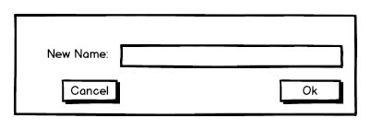

Figure 21 Rename window draft

## Functional Design

Most of the interactions are done within the main window in this software, except a few that will call the other windows described above. We will take a look to how the interaction with these windows are done in the software.

### Starting assistant

When we start the software the first interaction is the starting assistant, we select a starting option, open or create a new project.

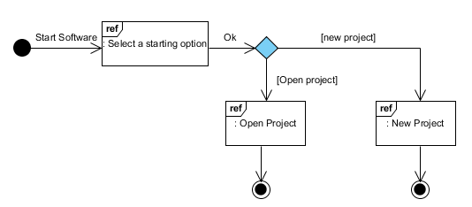

Figure 22 Interaction Diagram Starting Assistant

Then depending on the option selected another window is opened, a simple file browser to open a project or the new project assistant to create a new project.

### New Project Assistant

The new project assistant proposes to enter a project name, and then it brings the user to the streaming parameters window.

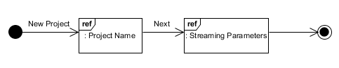

Figure 23 Interaction Diagram New Project Assistant

### Streaming Parameters

The streaming parameters window propose to the user to select a streaming platform in a list, the user has to enter his streaming key for this platform, then he can choose to end the configuration or to change the advanced parameters.

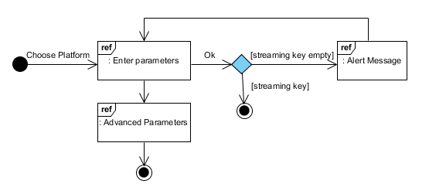

Figure 24 Interaction Diagram Streaming Parameters

### Advanced Parameters

The advanced parameters window propose to the user to change a lot of streaming parameters as we can see in the user interface part. The user can change these parameters and then save or cancel. The parameters in the auto configuration part can be changed only if the user select “disable” in the Enable/Disable auto configuration option.

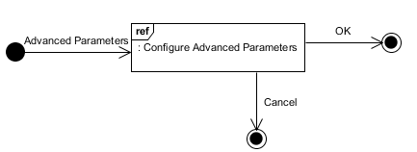

Figure 25 Interaction Diagram Advanced Parameters

### Rename

The user can choose to rename his project after creating it, a simple window to enter the new name is displayed, the user can save the new name or cancel the change.

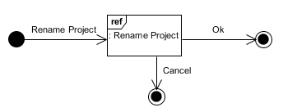

Figure 26 Interaction Diagram Rename

## Classes Design

This software requires an important number of classes to work, due to its complexity. To handle that correctly we implemented a design pattern, the model view controller pattern (MVC).

### Design Pattern MVC

The MVC pattern is very useful to structure the architecture of the software. Indeed this pattern separates the classes into three parts.

**The Model:** It contains the data classes of the software, example in our software the *camera* class.

**The View:** It contains the visual part of the software, the user interface, example in our software the *mainwindow* class.

**The controller:** This is what control everything, when an action is asked by a user, the view send the information to the controller who will apply it by using the model if necessary. In our software this is the *controller* class.

**Example of the use of the MVC in our software:**

when the user want to rename a project. The user enter the new project name in the view and tell the view “I want to save this new name”, the view call the controller and tell him “the user want to change the name of the project with this one”, the controller will change the name by calling the project model and tell him “your name is now this one”.

The point for this software to use this pattern was to structure the classes and make it easier to implement.

### Overall Class Diagram

Here is an overall description of each class, with the name and the position in the MVC pattern.

| Class | MVC | Description |
| --- | --- | --- |
| Source | Model | Super class of the different sources describe the name and the type of a source. |
| Camera | Model | Model of a camera, inherited from the source. |
| Microphone | Model | Model of a microphone, inherited from the source. |
| Project | Model | Model of a project, describe the name, the configuration of a project. |
| Controller | Controller | The main controller of the software. |
| StreamThread | Controller |  |
| StreamTools | Controller |  |
| AvTools | Controller |  |
| *ChooseCreateOpenProject* | View | View of the starting assistant. |
| *MainWindow* | View | View of the main window. |
| *NewProjectAssistant* | View | View of the new project assistant. |
| *PlatformSelectionWindow* | View | View of the streaming parameters. |
| *RenameProjectWindow* | View | View of the rename window |
| *StreamingParametersConfigurationWindow* | View | View of the advanced parameters |

### Class Diagram

Here is the class diagram of the software.

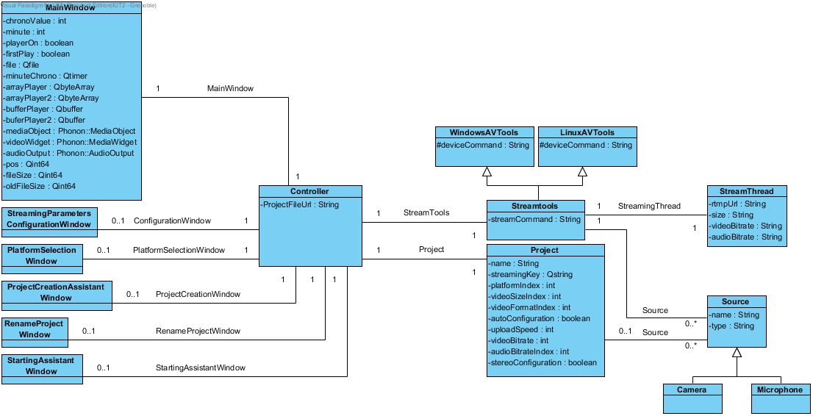

Figure 27 StreaMe Class Diagram

# Chapter 5: Implementation

## Languages, Libraries and Tools

### C++

### QT

### Qt Creator

### Phonon

Phonon is a cross-platform multimedia framework that enables the use of audio and video content in Qt applications.

With Phonon you can easily implement a video and audio player into your application, by using classes like mediaObject for the video source, audioOutput for the audio and videoWidget for the display of the mediaObject.

To use phonon into a Qt project we just have to add the following line in the qmake project file:

QT += phonon

And include the classes needed like this:

#include <phonon/MediaSource>

### FFMPEG

### Broadcasting Platforms

## Prototype Implementation

In this part we will see how each of the main functionalities are implemented in the prototype but also how the user interface has been created

### User Interface

### Project File

For the storage of the project data we decided to use the XML file format to define our own file storage format policy. The goal of using this format is to make it readable also for humans using a simple text editor to simplify the debugging. Indeed, using this standard an experimented user can easily understand what configuration was selected by reading the project file. Also, the C++ framework we use (QT) include methods to create and read XML formatted files. These included methods accentuated our decision to use it because it also simplified the algorithm we had to perform to open a project from an existing project file.

Conform to the standard way of saving files into software, we decided to allow the user to save a project using two different way (save and save as). Also, to simplify the finding of the StreaMe project file, a StreaMe file type was defined (.sm). This file type helps the user when this one wants to open a project file because it allows filtering the files by this extension easily.

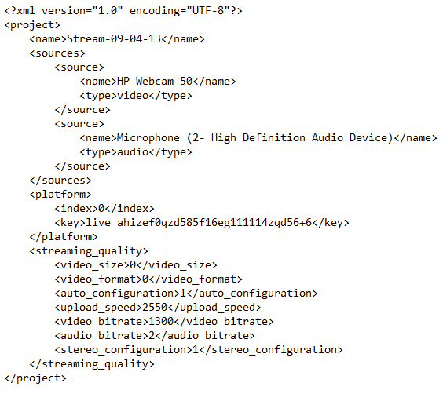

Figure 28 Example of project file

Into this storage file we choose to store each part of what defined the project itself.



This line is just the xml header using for when loading the project file because this line define the encoding of the file and the xml version used. Without this line the Qt xml parser is not able to get the information form the file.



This line is just basicly the name of the project defined into the software. This name can be diferent that the name of the project file.

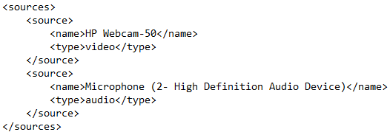

This part of the project file define each used source with his name as it apear into the software and the type of the source.

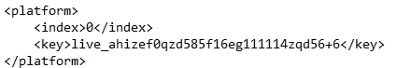

These information are the authentication information for the broadcasting platform.

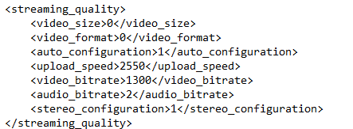

Finally this part is the most important because it save every configuration for the audio and the video quality the user want to have when streaming the project.

### Video Capture

### Video Broadcast

### Video Display

The video display is implemented in the main window. It simply display the video captured with a delay of only five seconds.

To display the video, a video file is created by ffmpeg when capturing and streaming, it means that what is send to the streaming platform is also stored in a video file.

To read and display this video file into our software we use the QT framework named “Phonon” as described above.

Creating the basic player with phonon was really simple with the following lines:

mediaObject = new Phonon::MediaObject(this);

videoWidget = new Phonon::VideoWidget(ui->videoPlayer);

Phonon::createPath(mediaObject, videoWidget);

audioOutput = new Phonon::AudioOutput(Phonon::VideoCategory, this);

Phonon::createPath(mediaObject, audioOutput);

The media object represents the video source, the video widget represents the player in the software, and the audio output represents the audio in output.

Now that we have our player defined we need to add a media to it to play it. To add the video that we capture with our software into the player we use, as we say above, a video file.

It will be very easy to play a completed and finished video file in our player, but the problem is that, because we are capturing the video and we want to display it with a small delay we need to play the file before it’s finished.

Play a not finished file in our player is not as simple as a finished file. To do that we need to read the current file, add it to a buffer, start playing the buffer, and before the video end read the current file again (which will not be the same as before, new frames will be in the video) and add it to the buffer, we do that will the capture is working.

Here is how we implement that the first time in C++:

file->setFileName("why.mpeg");

file->*open*(QIODevice::ReadOnly);

fileSize=file->*size*();

*array1 += file->read(file->*size*());

bu->setBuffer(array1);

mediaObject->setCurrentSource(bu);

mediaObject->play();

We can see in detail that we open the file, read in fully, add it to a bytes array and then add that array to a buffer, we set the buffer as a source for the media object and then play it.

For the rest of the video a signal will be send when the video is almost finished, we will then in the same way add the new part of the video to the buffer.

*(schema pour resumer le fonctionnement)*

## Linux Implementation

Description how the software is implemented on linux

## Installer on Windows and Linux

### Windows

### Linux

## Others ???

# Chapter 6: Testing and Evaluation

# Chapter 7: Conclusion and Further Work

## Further Work

## Conclusion